Adaptive AI-Powered Placement Preparation Platform Using Multi-Agent Intelligence for Personalized Career Readiness
Sathya Sri . R , Dr. G. Sangeetha ,
Department of Computer Science And Engineering
Vels Institute of Science , Technology and Advanced Studies(VISTAS),Pallavaram,Chennai,India
SathyaSri6075@gmal.com , sangeethag.se@vistas.ac.in

Abstract— Placement preparation has become an integral part of every undergraduate student’s journey in computer science and related fields. To overcome the hard recruitment process, the students are now expected to face the difficult tests of aptitude, verbal ability, technical knowledge, and coding tests. Most of the traditional platforms serving such a domain offer a set of questions and set of difficulty levels for each question which fails to take into account the nuanced difference in performance of each student. The paper introduces EduCoach AI, an adaptive AI-based placement preparation platform providing personalized career-readiness training based upon the continuous performance analysis of the students. The system includes Technical Multiple-Choice Questions, Verbal Multiple-Choice Questions, Aptitude Tests, and Coding Challenges – which are performed within a web-based environment. The student interactions with the system are captured as scores, accuracy, number of attempts, student performance on topics, and assessment records in the database and used to determine the students' strengths and weaknesses and their placement-readiness estimates. All this is complemented with an Adaptive learning component and a Machine Learning-based performance analysis component, which recommends the next question level and learning area to practice. A multi-agent based architecture consisting of Assessment, Performance Analysis, Adaptive Learning and AI Mentor Agents is proposed, with each agent being independent to a specific domain of placement preparation, but operating collaboratively to create a common personalized learning cycle. The system provides a viable method to move away from the traditional placement test, question-answer approach and towards a continually changing, personalized and performance-based learning environment. Key Terms—Artificial Intelligence, Adaptive Learning, Machine Learning, Multi-Agent Systems, Personalized Learning, Placement Preparation, Student Performance Analysis, Career Readiness.

I. INTRODUCTION
The Undergraduate student's campus recruitment is a crucial moment in his/her academic life. Mostly aptitude, verbal, technical and coding test forms the bulk of software and IT recruitment. With the help of the online platform, the students struggle to identify the key areas that need improvement, and choose the right resources for preparation. Some students are good at technical skills while others may have a flair for verbal skills. Thus, a uniform approach for training the students will not yield the best results.
A lot of learning management systems offer a standard set of material and testing pattern. Certainly such systems are an essential part of students' learning curve but they don't provide any support to personalize and monitor the student's performance. Maintaining personalization of the training programs based on marks, accuracy, and topic-wise performance is difficult with the existing systems. The use of Artificial Intelligence and Machine Learning, however, can be used to keep a list of topics that the student has to work on, and guide the learning courses that are most relevant.
The EduCoach AI is a web-based platform with a blended approach of assessment, performance analysis, adaptive learning, and AI mentor. The application has Technical MCQ's, Verbal MCQ's, Aptitude and Coding Challenges modules. The overall system is based on a hybrid multi-agent model, which comprises mainly Assessment Agent, Performance Analysis Agent, Adaptive Learning Agent, and AI Mentor Agent. The primary focus of the study is to develop a continuous learning loop, that recommends the next set of learning material based on the performance of the student in any particular topic. The system can automatically identify weak points, and recommend the tests, chapters and learning materials to be improved intelligently and individually.
II. RELATED WORK
Research within the field of personal and adaptive learning has focused on harnessing learner data to offer personalized educational experiences to students. The recently published articles on the personalized adaptive learning in higher education suggest that such data as the prior knowledge or achievement results can be utilized to recommend relevant educational resources to learners, thus improving their performance and engagement. However, there are a number of technological and implementation-related concerns related to such systems. Intelligent Tutoring Systems, in particular, are designed to provide individualized instruction and feedback. Nevertheless, most of the research and applications are focused on general education, whereas adaptive individual learning has been underdeveloped in terms of individual preparation for placement.
Machine Learning, in particular, has been used extensively for predictive modeling of student performance. Tree-based models and other algorithms can be applied to represent student performance patterns learned by the model. However, such data should be further analyzed to extract actionable insights which would be applicable for improving the performance of each learner individually.
Multi-agent systems represent another direction in which personalized learning can be implemented through collaborative agents. Recent research has demonstrated that multiple AI agents can be used to address different aspects of a complex task, such as education, thus providing individual help and support.
Therefore, it can be concluded that adaptive, individual learning for the purpose of placement preparations may greatly benefit from pre-existing research directions, such as Machine Learning, intelligent tutoring systems, and multi-agent interactions. EduCoach AI caters to the necessity of a comprehensive system for placement preparations, utilizing Technical, Verbal, Aptitude, and Coding assessments, analyzing them to derive actionable insight, individually recommending, and providing personalized AI Coaching.
III. PROPOSED SYSTEM ARCHITECTURE

The proposed EduCoach AI system architecture involves integration with various components such as the student interface, assessment, database, Machine Learning, and adaptive learning and AI mentoring. Modularity allows one to progressively enhance the individual elements without affecting the whole system.
The Student Login, Student Registration, Student Dashboard, Subject Selection, Tests, Performance Charts, Coding and the AI Mentor sections are included in the Presentation Layer. It is implemented with HTML, CSS and JavaScript (with visualization components).
Python, Application Layer, is used to control authentication, routing, sessions, test selection and answer submission as well as score calculation and communication between the layers of the system using Flask.
Assessment Layer is responsible for Technical MCQs, Verbal MCQs, Aptitude, Coding Challenges. Questions are grouped by the subject, topic and level of difficulty. System processes answers, scores and correctness and stores the results.
The Data Layer uses SQLite to store user information, questions, attempts to solve the questions, history of problem-solving and coding submission by the user. The system can track areas of strengths and growth in past assessment data.
The Intelligence Layer relies on the use of Pandas and Scikit-learn to undertake student performance analysis, support readiness prediction and make adaptive decisions. The last of these are four agents in the Multi-Agent Intelligence Layer: Assessment Agent, Performance Analysis Agent, Adaptive Learning Agent and AI Mentor Agent. All the elements are used together to create a continuous cycle of assessment, analysis, adaptation, recommendation and reassessment.
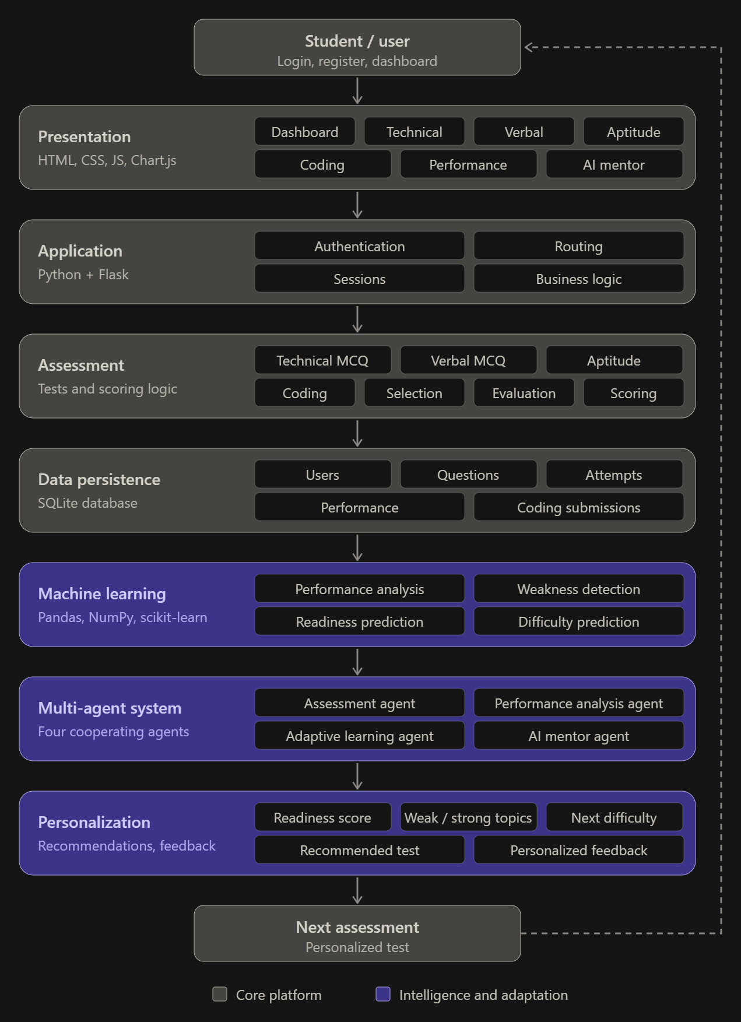
Fig.1. System Architecture
IV. MULTI-AGENT INTELLIGENCE MODEL
One of the major advantages of this multi-agent model is that the essential roles of the EduCoach AI can be divided into four separate roles: Assessment Agent, Performance Analysis Agent, Adaptive Learning Agent, and AI Mentor Agent. This separation will enable the system to be modular and will connect the assessment results to personal learning choices.
The Assessment Agent controls the selection of the questions, evaluation of the answers, computing the scores, accuracy, and recording of the attempts. The Performance Analysis Agent analyses scores, accuracy, topic-wise performance, attempts and previous history and also helps to identify the weak and strong points of the students.
Analyzed Performance is the basis for Adaptive Learning Agent's selection of the next activity in the learning and difficulty level of questions. Lower scores are easier or remedial practice sentences and higher scores are more challenging sentences. AI Mentor Agent provides tailored feedback and identifies which areas need improvement.
One continuous track of assessment and analysis, adaptation and mentoring among the four agents leads to more individualized and responsive placement preparation.
VI. ADAPTIVE PERFORMANCE ANALYSIS
Adaptable performance analysis is another unique feature of EduCoach AI as compared to traditional question book. An assessment is recorded in the system and student is provided with a student's profile which includes an evaluation of student's score, accuracy, topic-by-topic assessment performance, number of attempts and student's assessment history.
The system is able to identify specific weak and strong topics based on the performance on each topic level. Student's readiness can be estimated using a Random Forest classifier as Low, Medium or High. Next, the next practice test will be at an appropriate level - tests with scores <70% will get easier practice, tests with scores between 70% and 90% will get medium level of practice, and tests with scores >90% will get more difficult practice.
Machine Learning thus provides readiness analysis and adaptive rules transform the performance results to become the next learning activity. results is assessing, analysing, adapting and re-assessing.

V.MATHEMATICAL FORMULATION
A. Accuracy
Accuracy measures how many questions the student answered correctly.
$$Accuracy=\frac{Correct Answers}{Total Questions}×100$$
B. Test Score
For an objective test where each question carries one mark:
$$Score=\sum_{i=1}^{N}{C_{i}}$$
where:
- N = total number of questions
- $C_{i}=1$if the answer is correct
- $C_{i}=0$ if the answer is incorrect
For 30 questions and 24 correct answers:
$Score=24/30$
3. Topic Performance Score
This is particularly important for your weak-topic detection.
$TPS_{t}=\frac{Correct_{t}}{Attempted_{t}}×100$
where t represents a particular topic.
4. Overall Performance Score
$OPS=w_{T}T+w_{V}V+w_{A}A+w_{C}C$
5. Placement Readiness Score
$PRS=\sum_{i=1}^{n}{w_{i}}X_{i}$
where:
- $X_{i}$= normalized performance feature
- $w_{i}$= importance weight
- $n$= number of features
Possible features include:
$X=\left[Technical,Verbal,Aptitude,Coding,Accuracy,Improvement\right]$
The result can be normalized to a 0–100 scale.
6. Adaptive Difficulty Formula / Rule
$$D_{next}=\left\{\begin{matrix}Easy, & Score<70\% \\ Medium, & 70\%≤Score≤90\% \\ Hard, & Score>90\%\end{matrix}\right.$$
Therefore:
$D_{next}=Hard$
7. Weakness Detection
$$WeakTopic\left(t\right)=\left\{\begin{matrix}1, & TPS_{t}<70\% \\ 0, & TPS_{t}≥70\%\end{matrix}\right.$$

8. Improvement Rate
$$IR=\frac{CurrentScore-PreviousScore}{PreviousScore}×100$$
9. Average Time per Question
$$ATQ=\frac{Total Test Time}{Number of Questions}$$

10. ML Model Formula
Conceptually:
$$\overset{ˆ}{y}=Mode\left\{T_{1}\left(X\right),T_{2}\left(X\right),…,T_{M}\left(X\right)\right\}$$
where:
- $X$= student-performance features
- $T_{i}$= individual decision tree
- $M$= number of trees
- $\overset{ˆ}{y}$= final predicted readiness class
11. Features Used by the ML Model

$$X=\left[S_{T},S_{V},S_{A},S_{C},Acc,Attempts,Time,Improvement\right]$$

where:
- $S_{T}$ = Technical score
- $S_{V}$= Verbal score
- $S_{A}$= Aptitude score
- $S_{C}$= Coding score
- $Acc$= Accuracy
- $Attempts$= Number of attempts
- $Time$= Time-related performance
- $Improvement$= Improvement rate
The model predicts:
$X→Readiness Class$
VI. IMPLEMENTATION
The proposed platform is implemented as a web application using Python and the Flask framework. It can be broadly divided into the four major modules described below.
A. User and Assessment Management:
This module handles the user registration and authentication. Once a student is authenticated, he/she can choose different types of modules such as aptitude, technical MCQ, and coding. This module pulls relevant questions from the question bank depending upon the type of module selected by the student.
B. Assessment and Evaluation Engine:
This module is responsible for displaying the questions, accepting answers, and calculating scores. The answers of aptitude and technical MCQ questions are automatically evaluated using the answer keys. The coding module displays coding questions and is linked with a secure coding server to evaluate the code submissions.
C. Performance Analysis and Recommendation:
This module stores the performance of the student in terms of scores, accuracy, and topics. It also recommends the topics that need more practice by comparing the current performance with previous performance.
D. Web App and Databases:
The web application is developed using the Flask framework and HTML/CSS/JS for the front end. SQLite database is used to store the details of the students, questions, performance, etc. The whole system is modular and can be expanded to include other AI-based modules such as assessment, analysis, recommendation, and placement-readiness analysis.
VII. RESULTS AND DISCUSSION
A .Results
The created EduCoach AI system is successfully integrated with the Technical MCQs, Verbal MCQs, Aptitude, Coding Challenges. The system allows users to monitor their results, accuracy, attempts, and performance in relation to particular topics. Moreover, it is possible to identify weak and strong areas and get recommendations. The system is adaptive to the user’s skill level based on the previous test result. The AI Mentor also provides personal guidance and feedback.
Fig.2.Login Page
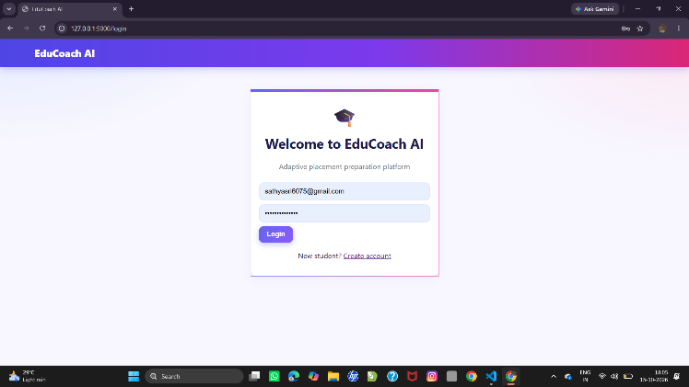

Fig.3. Home Page
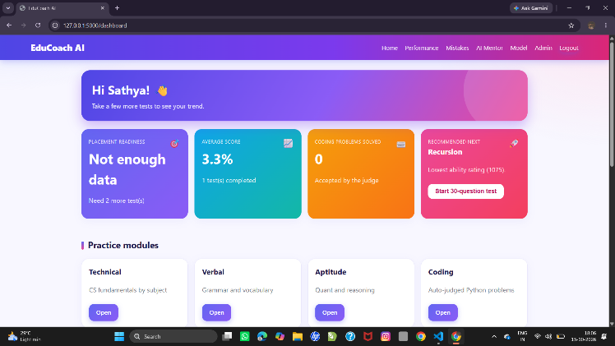

Fig.4.Performance Analytics Page
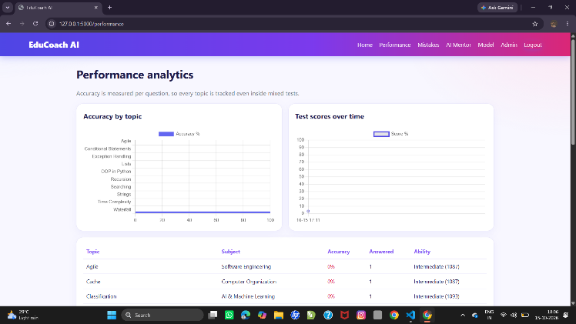

Fig.5. Models Page
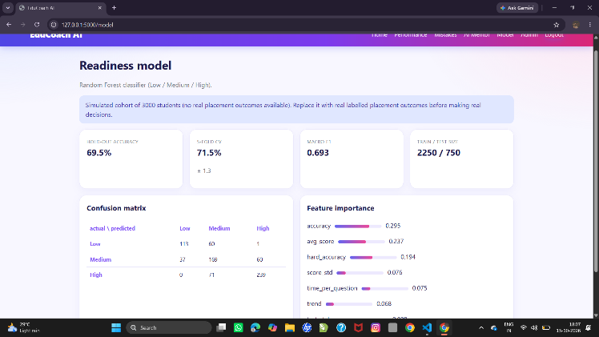

Fig.6. Admin Page
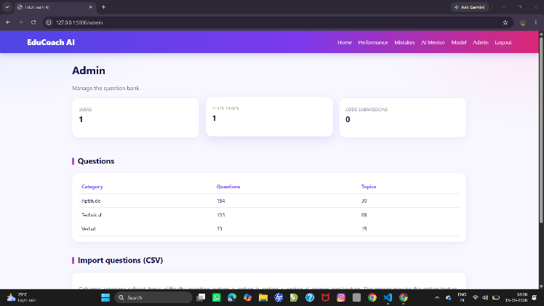

Fig.7. AI Mentor Page
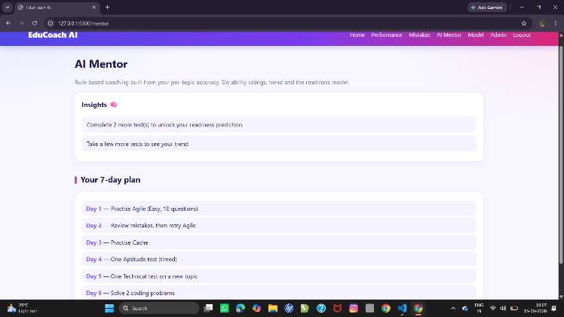

B. Discussion
The results show that EduCoach AI can provide a personalized placement preparation experience instead of using fixed tests for all students. The multi-agent architecture helps analyze performance, select suitable difficulty, recommend topics, and provide feedback. However, the effectiveness of the ML model depends on the availability of sufficient student-performance data. The system can be improved further using larger datasets and real-world student evaluations.

VIII. CONCLUSION AND FUTURE WORK

EduCoach AI is a novel adaptive AI-based placement preparation framework that addresses the importance of personalized career readiness solutions. This framework offers multiple-choice questions (MCQs) including Technical, Verbal, Aptitude, and Coding Challenges as a unified system and relies on the analysis of history, scores, accuracy, and performance by topic to identify learning trends and recommend relevant activities.
The discussed prototype implements Assessment, Performance Analysis, Adaptive Learning, and AI Mentor agents that allow for individualizing the placement preparation process according to the test-taker’s needs by modifying the difficulty level and other characteristics of tests. The presented software system illustrates the effectiveness and applicability of such an approach in context of AI and Machine Learning-enabled adaptation and personalization. Future work on EduCoach AI may involve the use of greater volumes of data, enhanced security measures, automated coding assessment, company-specific readiness preparation, greater precision in readiness evaluation, and a more complex AI mentor. In conclusion, the developed by an adaptive placement preparation framework creates a cycle of learning and assessing that individualizes the preparation for each student.

XI.REFERENCES
[1] S. M. Shemshack and J. A. Spector, “A systematic literature review of personalized learning terms,” Smart Learning Environments, vol. 7, 2020.
[2] M. A. Castro, M. M. D. Tumibay, and related authors, “Personalized adaptive learning in higher education: A scoping review of key characteristics and impact on academic performance and engagement,” Educational Technology Research and Development, 2024.
[3] A. Fortuna, F. Prasetya, A. D. Samala, S. Rawas, S. Criollo-C, D. Kaya, M. Raihan, W. Andriani, D. Safitri, and R. A. Nabawi, “Artificial intelligence in personalized learning: A global systematic review of current advancements and shaping future opportunities,” Social Sciences & Humanities Open, vol. 12, 102114, 2025, doi: 10.1016/j.ssaho.2025.102114.
[4] Z. Hao, J. Cao, R. Li, J. Yu, Z. Liu, and Y. Zhang, “Mapping student-AI interaction dynamics in multi-agent learning environments: Supporting personalized learning and reducing performance gaps,” Computers & Education, 2025, doi: 10.1016/j.compedu.2025.105472.
[5] N. Gupta and S. Heggond, “Agentic artificial intelligence-driven tutoring: A multi-agent cognitive architecture for personalized adaptive learning in education,” International Journal of Applied Resilience and Sustainability, vol. 2, no. 2, 2026.
[6] “An adaptive multi-agent architecture with reinforcement learning and generative AI for intelligent tutoring systems: A Moodle-based case study,” Applied Sciences, vol. 16, no. 3, 1323, 2026, doi: 10.3390/app16031323.
[7] “Predicting student performance: A comprehensive review of machine learning, deep learning, and explainable AI approaches,” Computers and Education: Artificial Intelligence, vol. 10, 100548, 2026.
[8] “Artificial intelligence in adaptive education: A systematic review of techniques for personalized learning,” Discover Education, 2025.
[9] “Using artificial intelligence to support self-regulated learning: A systematic review of empirical research,” Learning and Individual Differences, vol. 128, 102917, 2026.
[10] B. Khosravifar, R. Azevedo, R. Feyzi-Behnagh, M. Taub, G. Biswas, and J. S. Kinnebrew, “Adaptive multi-agent architecture to track students' self-regulated learning,” in Proceedings of the International Conference on Intelligent Tutoring Systems, 2013.

